**1.**

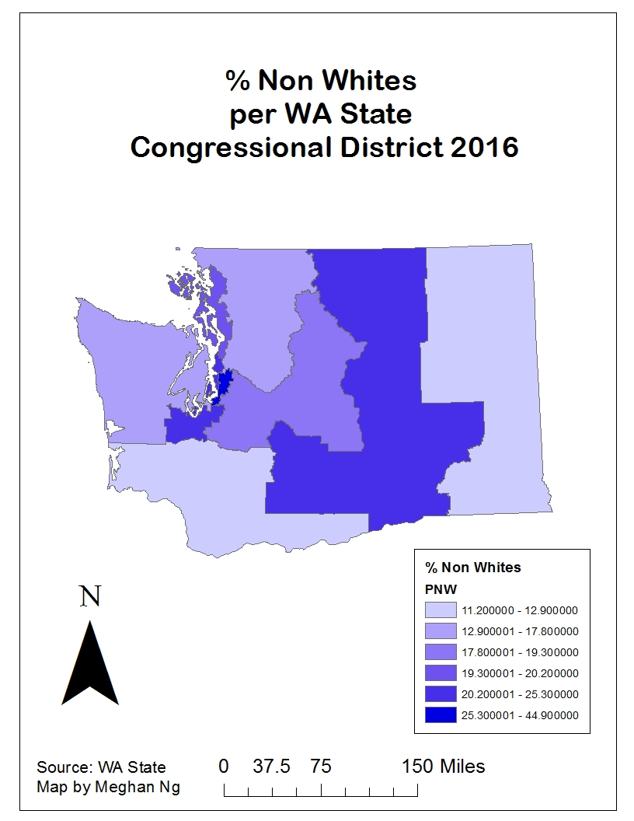

**A.  On your map, why are some congressional districts bigger than others (in terms of total area)? [1 pt.]**

Some congressional districts are bigger than others in terms of total area because each congressional district required a predetermined number of people living in them. Places with a large population within a small area will have a congressional district with a small area and vice versa.

**B.  Which congressional district has the highest % of the population that is non-white and what is that %? Does this constitute a majority-minority district?  [1 pt.]**

The congressional district with the highest percent of the population that is non-white is District 9 with 44.9% of its population non-white. It does not constitute a majority-minority district.

**2. Mission 2**

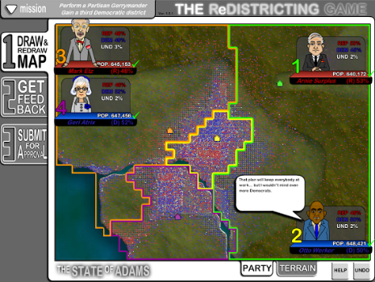

**2. Mission 3**

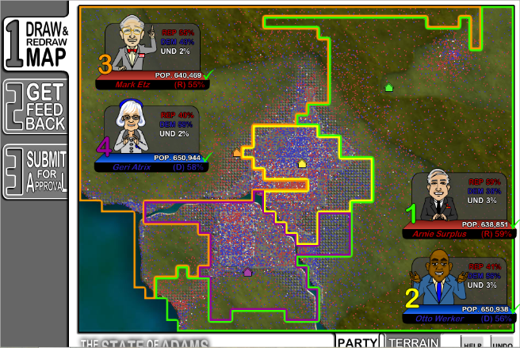

**2. Mission 4**

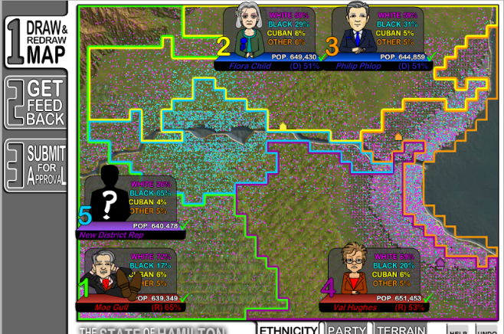

**C.  Based on your experience with the three simulations you just did (partisan, bipartisan, and racial gerrymandering) write a one-page reflection on the Economist quote at the start of the assignment (“In a normal democracy, voters choose their representatives. In America, it is rapidly becoming the other way around.”) that addresses the following questions:**

**i.  Is this an accurate description of redistricting in the US?**

**ii.  What about in Washington State?**

**iii.  Should such gerrymandering practices be permitted?**

**iv.  Why or why not?**

**Be sure to justify your responses with references to your simulations. [3 pts]**

The quote is not a complete accurate description of redistricting in the U.S. I do not agree with the quote because I do not believe that voters choosing their representatives is “rapidly becoming the other way around.” Some states including Washington, California, Idaho, and Arizona have already implemented independent commissions to prevent elected officials from gerrymandering in their favor. This allows us to have faith that the states with this type of commission understand that gerrymandering cannot be taken too far without harboring negative consequences. The fact that there are states with this type of commission could predict that other states in the future may adopt an independent commission as well to prevent representatives from choosing their voters.

The quote therefore is also not representative of redistricting in Washington State. Since Washington State took up an independent commission for redistricting, it has taken a big step against the harmful effects of gerrymandering as well as the representatives from selecting their voters for their own gain. As we can see in the current map of congressional districts in the state, there are rarely any unusual slithers in any congressional districts, meaning there are no signs of gerrymandering.

Commissions should be cautious and limit their usage of gerrymandering to avoid unfair redistricting in their favor. From playing the redistricting game, it was clear that gerrymandering can heavily favor candidates for reelection instead of listening to what their voters really want. When I heavily created slithers that outright showed gerrymandering and submitted the map for approval, it was still approved. Too much gerrymandering can corrupt a state, therefore the only key to allow gerrymandering to still occur when redistricting is for commissions that include candidates in elections to be honest with their voters and listen to them before making permanent decisions.